一：通用配置（ob和oms都配置）

1：配置时钟源（192.168.31.7是测试ip，修改为ob机器对应的ip）
vi /etc/chrony.conf
# Use public servers from the pool.ntp.org project.
# Please consider joining the pool (http://www.pool.ntp.org/join.html).
server 192.168.31.7 minpoll 4 maxpoll 6 iburst
maxslewrate 500
local stratum 10

#pool pool.ntp.org iburst
#server ntp.ntsc.ac.cn iburst
#server ntp1.aliyun.com iburst
#server cn.pool.ntp.org iburst

# Record the rate at which the system clock gains/losses time.
driftfile /var/lib/chrony/drift

# Allow the system clock to be stepped in the first three updates
# if its offset is larger than 1 second.
makestep 1.0 3

# Enable kernel synchronization of the real-time clock (RTC).
rtcsync

# Enable hardware timestamping on all interfaces that support it.
#hwtimestamp *

# Increase the minimum number of selectable sources required to adjust
# the system clock.
#minsources 2

# Allow NTP client access from local network.
allow all

# Serve time even if not synchronized to a time source.
#local stratum 10

# Specify file containing keys for NTP authentication.
#keyfile /etc/chrony.keys

# Get TAI-UTC offset and leap seconds from the system tz database.
#leapsectz right/UTC
# Specify directory for log files.
logdir /var/log/chrony

# Select which information is logged.
#log measurements statistics tracking
2：检查时钟源配置情况
systemctl restart chronyd.service
chronyc sources
systemctl enable chronyd.service

3：配置hosts
# vi /etc/hosts
192.168.31.7 ob
192.168.31.8 oms

4：关闭防火墙
systemctl disable firewalld
systemctl stop firewalld
systemctl status firewalld

5：关闭SElinux
vi /etc/selinux/config
SELINUX=disabled

6：查看透明大页是否关闭
cat /sys/kernel/mm/transparent_hugepage/enabled
echo never > /sys/kernel/mm/transparent_hugepage/enabled

7：查看IO调度策略
cat /sys/block/sd[bc/nvme]/queue/scheduler

Oceanbase节点：数据盘（存放 SSTable、事务日志）对 IO 延迟和吞吐量敏感，若为 SSD/NVMe，建议修改为none或kyber；若为 HDD，建议mq-deadline
OMS/OCP节点：IO 压力相对较低，若用 SSD 可沿用mq-deadline或改为kyber，无需强制修改

8：关闭numa
cat /etc/default/grub
GRUB_CMDLINE_LINUX="resume=/dev/mapper/klas-swaprd.lvm.lv=klas/root rd.lvm.lv=klas/swap rhgb quiet numa=off"

9：配置本地yum源
mkdir -p /mnt/kylin

# 备份原有源配置
mkdir /etc/yum.repos.d/bak
mv /etc/yum.repos.d/*.repo /etc/yum.repos.d/bak/
# 创建本地源配置文件
cat > /etc/yum.repos.d/local.repo << EOF
[local-repo]
name=Kylin V10 Local Repository
baseurl=file:///mnt/kylin
gpgcheck=0
enabled=1
EOF
mount /dev/sr0 /mnt/kylin/
yum clean all
yum makecache
yum list | grep gcc

#先分区后创建
3：创建admin用户并对目录赋权
groupadd -g 500 admin
useradd -u 500 -g admin admin
chown admin:admin -R /home
chown admin:admin -R /data
passwd admin
#hb48250302!

4：修好内核参数
# vi /etc/sysctl.conf
net.core.somaxconn = 2048
net.core.netdev_max_backlog = 10000
net.core.rmem_default = 16777216
net.core.wmem_default = 16777216
net.core.rmem_max = 16777216
net.core.wmem_max = 16777216

net.ipv4.ip_local_port_range = 3500 65535
net.ipv4.ip_forward = 0
net.ipv4.conf.default.rp_filter = 1
net.ipv4.conf.default.accept_source_route = 0
net.ipv4.tcp_syncookies = 0
net.ipv4.tcp_rmem = 4096 87380 16777216
net.ipv4.tcp_wmem = 4096 65536 16777216
net.ipv4.tcp_max_syn_backlog = 16384
net.ipv4.tcp_fin_timeout = 15
net.ipv4.tcp_max_syn_backlog = 16384
net.ipv4.tcp_tw_reuse = 1
net.ipv4.tcp_slow_start_after_idle=0
net.ipv4.ip_local_reserved_ports = 62881-63881

vm.swappiness = 0
kernel.core_pattern = /data/1/core-%e-%p-%t
vm.min_free_kbytes = 2097152
vm.overcommit_memory = 0

fs.aio-max-nr=1048576
vm.max_map_count=655360
vm.nr_hugepages = 0

# sysctl -p

###挂载ob机器
mkdir -p /data/log1 /data/1
pvcreate /dev/sdb
vgcreate vg_ob /dev/sdb
lvcreate -L300G -n home vg_ob
lvcreate -L600G -n log vg_ob
lvcreate -L1024G -n data vg_ob
mkfs.ext4 /dev/mapper/vg_ob-home
mkfs.ext4 /dev/mapper/vg_ob-log
mkfs.ext4 /dev/mapper/vg_ob-data

[root@danob kylin]#blkid
/dev/mapper/vg_ob-log: UUID="3fa6d181-99f1-45ce-8c28-53a6f55b9600" BLOCK_SIZE="4096" TYPE="ext4"
/dev/mapper/vg_ob-data: UUID="c471ca90-4e75-4e9a-9442-0e9a66797f78" BLOCK_SIZE="4096" TYPE="ext4"
/dev/mapper/vg_ob-home: UUID="b8597696-e045-40fc-8030-b1814ee1ecb0" BLOCK_SIZE="4096" TYPE="ext4"

[root@danob kylin]# vi /etc/fstab
UUID=b8597696-e045-40fc-8030-b1814ee1ecb0 /home ext4 defaults,noatime,nodiratime,barrier=0 0 0
UUID=3fa6d181-99f1-45ce-8c28-53a6f55b9600 /data/log1 ext4 defaults,noatime,nodiratime,barrier=0 0 0
UUID=c471ca90-4e75-4e9a-9442-0e9a66797f78 /data/1 ext4 defaults,noatime,nodiratime,barrier=0 0 0
[root@danob kylin]# mount -a
[root@danob kylin]# df -h

####挂载oms机器
mkdir /data/oms
pvcreate /dev/sdb
vgcreate vg_ob /dev/sdb
lvcreate -L300G -n home vg_ob
lvcreate -L600G -n oms vg_ob
mkfs.ext4 /dev/mapper/vg_ob-home
mkfs.ext4 /dev/mapper/vg_ob-oms

[root@danoms kylin]#blkid
/dev/mapper/vg_ob-home: UUID="499bb32b-81ab-4ea4-87f7-4101a98577c9" BLOCK_SIZE="4096" TYPE="ext4"
/dev/mapper/vg_ob-oms: UUID="0eea3025-ad50-437f-bc71-839493b358cb" BLOCK_SIZE="4096" TYPE="ext4"

[root@danoms kylin]# vi /etc/fstab
UUID=499bb32b-81ab-4ea4-87f7-4101a98577c9 /home ext4 defaults,noatime,nodiratime,barrier=0 0 0
UUID=0eea3025-ad50-437f-bc71-839493b358cb /data/oms ext4 defaults,noatime,nodiratime,barrier=0 0 0

[root@danoms kylin]# mount -a
[root@danoms kylin]# df -h

安装软件包
[root@ob ~]# rpm -ivh obclient-2.2.5-20231227133752.el7.x86_64.rpm
Verifying... ################################# [100%]
准备中... ################################# [100%]
正在升级/安装...
1:obclient-2.2.5-20231227133752.el7######################## [100%]

5：重启机器
reboot

只在ob机器上安装
[admin@ob ~]$ tar -xvf oceanbase-standalone-all-in-one-4.2.5_bp6_hotfix1_20251009.el7.x86_64.tar.gz

[admin@ob bin]$ cd /home/admin/oceanbase-standalone-all-in-one/bin
[admin@ob bin]$ ./install_obd.sh

我们信任您已经从系统管理员那里了解了日常注意事项。
总结起来无外乎这三点：

#1) 尊重别人的隐私。
#2) 输入前要先考虑(后果和风险)。
#3) 权力越大，责任越大。
##设置的admin密码
[sudo] admin 的密码：********
install obd as normal user
There may be a risk of mixing the installation of OBD through yum and the all-in-one installation package in the future. We recommend that you re-execute the install.sh script using root or sudo.
Are you willing to install it using root or sudo?[y/n]
Enter 'y' exit, re-execute the install.sh script using root or sudo. 'n' continue.n
Trace ID: 58be8eac-b565-11f0-bef3-000c298a1caa
If you want to view detailed obd logs, please run: obd display-trace 58be8eac-b565-11f0-bef3-000c298a1caa
name: alertmanager
version: 0.28.1
release:32025073111.el7
arch: x86_64
md5: c5fe05fcc8263b83f6d0602a871d7e1a7a79bdb8
size: 69543154
add /home/admin/oceanbase-standalone-all-in-one/rpms/alertmanager-0.28.1-32025073111.el7.x86_64.rpm to local mirror
name: grafana
version: 7.5.17
release:1
arch: x86_64
md5: 1bf1f338d3a3445d8599dc6902e7aeed4de4e0d6
size: 177766248
add /home/admin/oceanbase-standalone-all-in-one/rpms/grafana-7.5.17-1.el7.x86_64.rpm to local mirror
name: libobclient
version: 2.2.10
release:22025032014.el7
arch: x86_64
md5: 733fb53ece28ac02cbeae5833c4b1d0edb9be895
size: 6915137
add /home/admin/oceanbase-standalone-all-in-one/rpms/libobclient-2.2.10-22025032014.el7.x86_64.rpm to local mirror
name: obagent
version: 4.2.3
release:200000032025071420.el7
arch: x86_64
md5: afec8b3bd8933798b6435f4a41b4cc4c74a76c5f
size: 72942598
add /home/admin/oceanbase-standalone-all-in-one/rpms/obagent-4.2.3-200000032025071420.el7.x86_64.rpm to local mirror
name: obclient
version: 2.2.10
release:22025032014.el7
arch: x86_64
md5: 683db864de2dbdeb76ed7b8cb337a838205b20b4
size: 51474004
add /home/admin/oceanbase-standalone-all-in-one/rpms/obclient-2.2.10-22025032014.el7.x86_64.rpm to local mirror
name: ob-deploy
version: 3.6.0
release:3.el7
arch: x86_64
md5: c48f82f988f8da512a8dc0bf0948b9584c3e7a34
size: 186044735
add /home/admin/oceanbase-standalone-all-in-one/rpms/ob-deploy-3.6.0-3.el7.x86_64.rpm to local mirror
name: oceanbase-diagnostic-tool
version: 3.7.0
release:22025090912.el7
arch: x86_64
md5: a67c4c06dbf1e3c1062f281470545eeaaf15110c
size: 71865303
add /home/admin/oceanbase-standalone-all-in-one/rpms/oceanbase-diagnostic-tool-3.7.0-22025090912.el7.x86_64.rpm to local mirror
name: oceanbase-standalone
version: 4.2.5.6
release:106010022025092415.el7
arch: x86_64
md5: 8376d05b3fe61d43d610df69a51801d86190e177
size: 1945593080
add /home/admin/oceanbase-standalone-all-in-one/rpms/oceanbase-standalone-4.2.5.6-106010022025092415.el7.x86_64.rpm to local mirror
name: oceanbase-standalone-libs
version: 4.2.5.6
release:106010022025092415.el7
arch: x86_64
md5: bb1da9ca64ec416d5b4e9425511eefebbb779e58
size: 7856
add /home/admin/oceanbase-standalone-all-in-one/rpms/oceanbase-standalone-libs-4.2.5.6-106010022025092415.el7.x86_64.rpm to local mirror
name: prometheus
version: 2.37.1
release:10000272025073110.el7
arch: x86_64
md5: d5fe6d40b6ccd6de9de036fd294966d044a3c328
size: 211224073
add /home/admin/oceanbase-standalone-all-in-one/rpms/prometheus-2.37.1-10000272025073110.el7.x86_64.rpm to local mirror
Trace ID: 5a476f50-b565-11f0-a341-000c298a1caa
If you want to view detailed obd logs, please run: obd display-trace 5a476f50-b565-11f0-a341-000c298a1caa
Disable remote ok
Trace ID: 5ee5aa4a-b565-11f0-a93f-000c298a1caa
If you want to view detailed obd logs, please run: obd display-trace 5ee5aa4a-b565-11f0-a93f-000c298a1caa

add auto set env logic to profile: /home/admin/.bash_profile

Execute this command to apply the environment config：`source ~/.oceanbase-all-in-one/bin/env.sh`
[admin@ob bin]$ source ~/.oceanbase-all-in-one/bin/env.sh
[admin@ob bin]$ obd web
start OBD WEB in 0.0.0.0:8680
please open http://192.168.31.7:8680

登录http://192.168.31.7:8680，如下图，按图中配置集群和租户

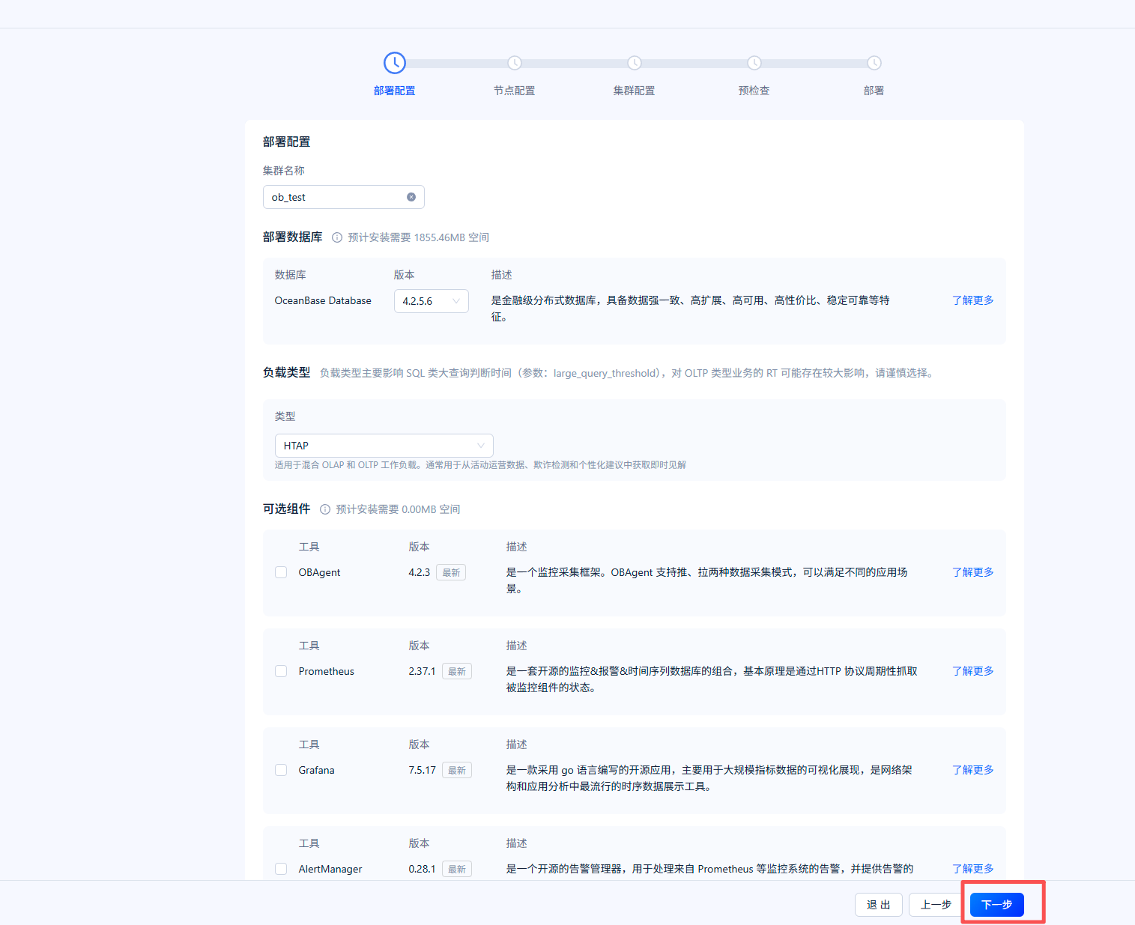

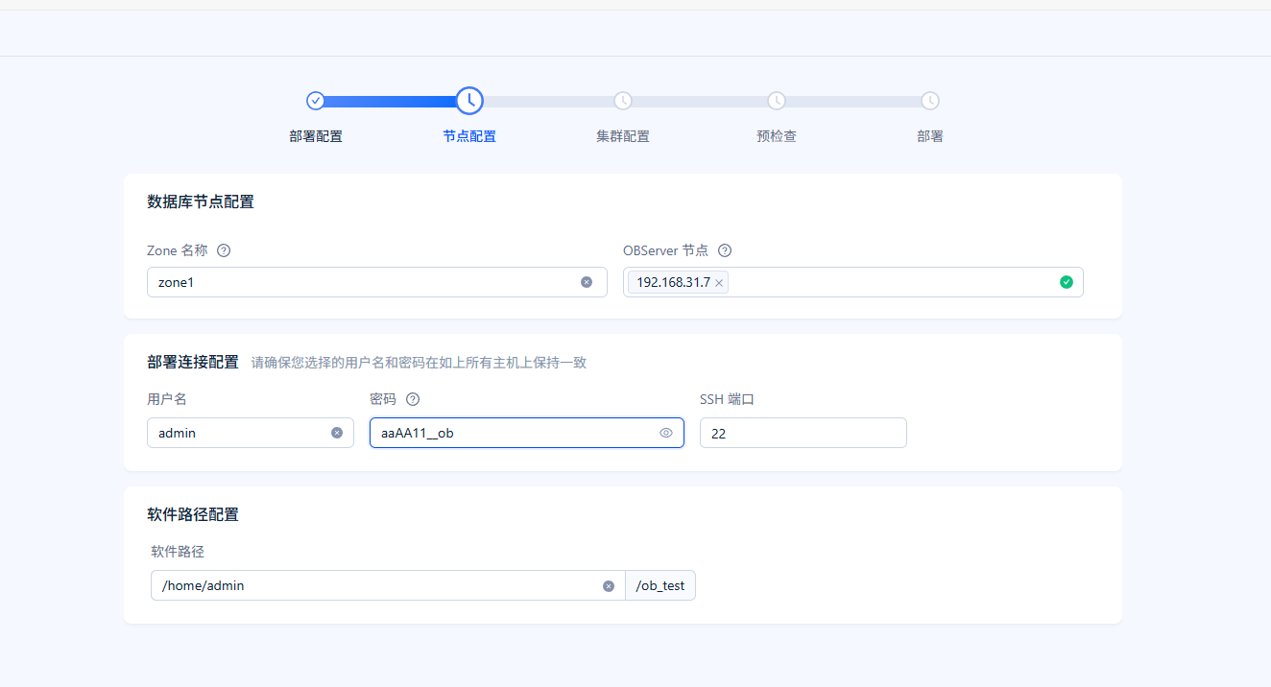
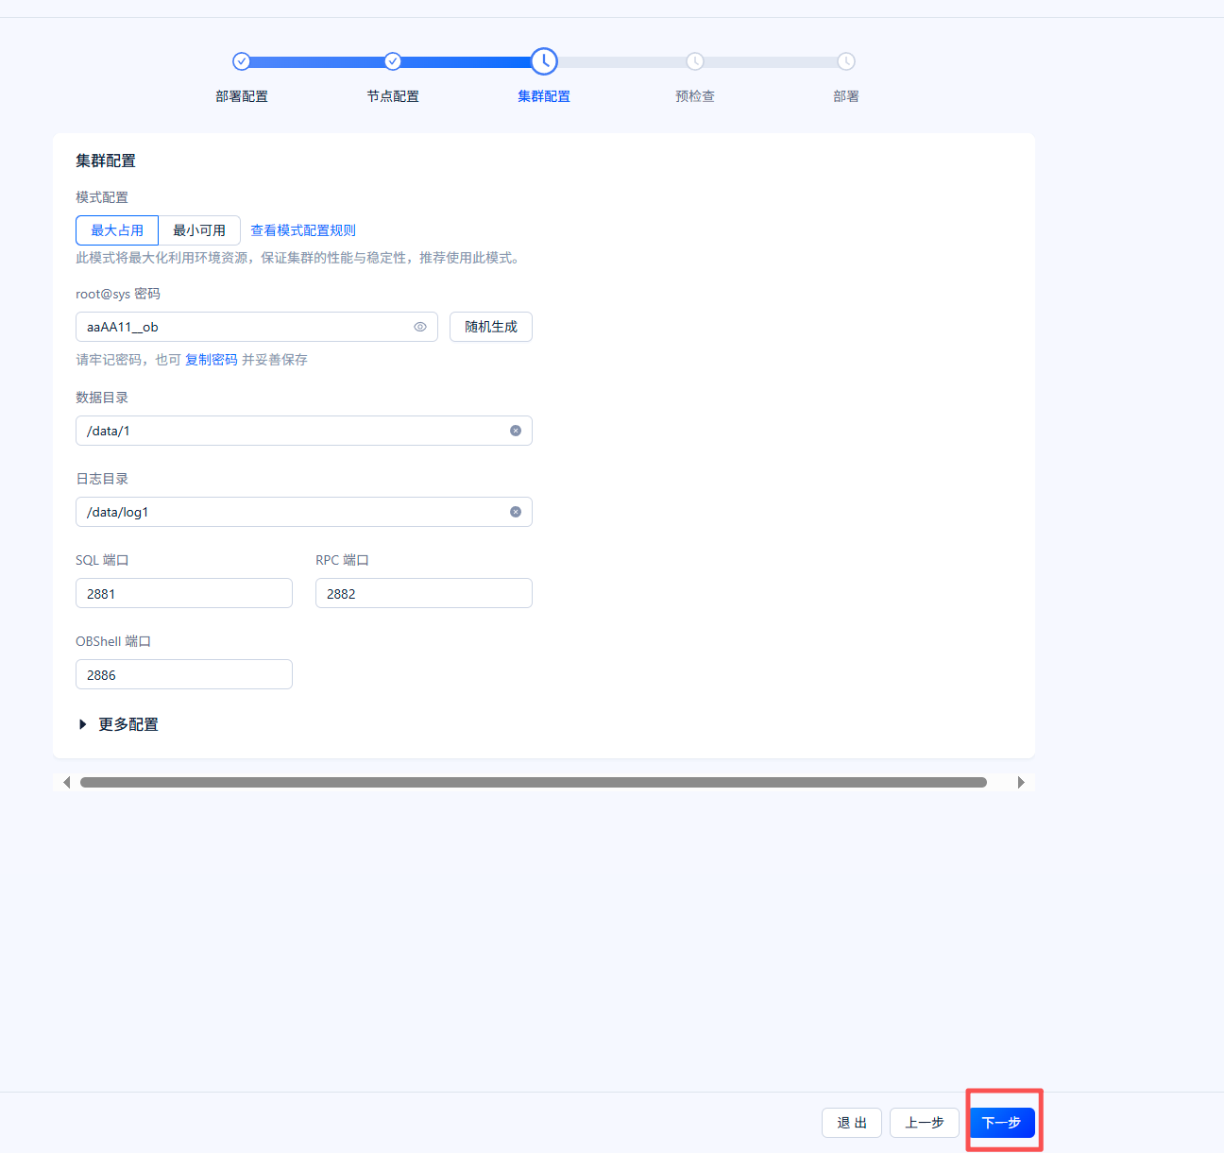
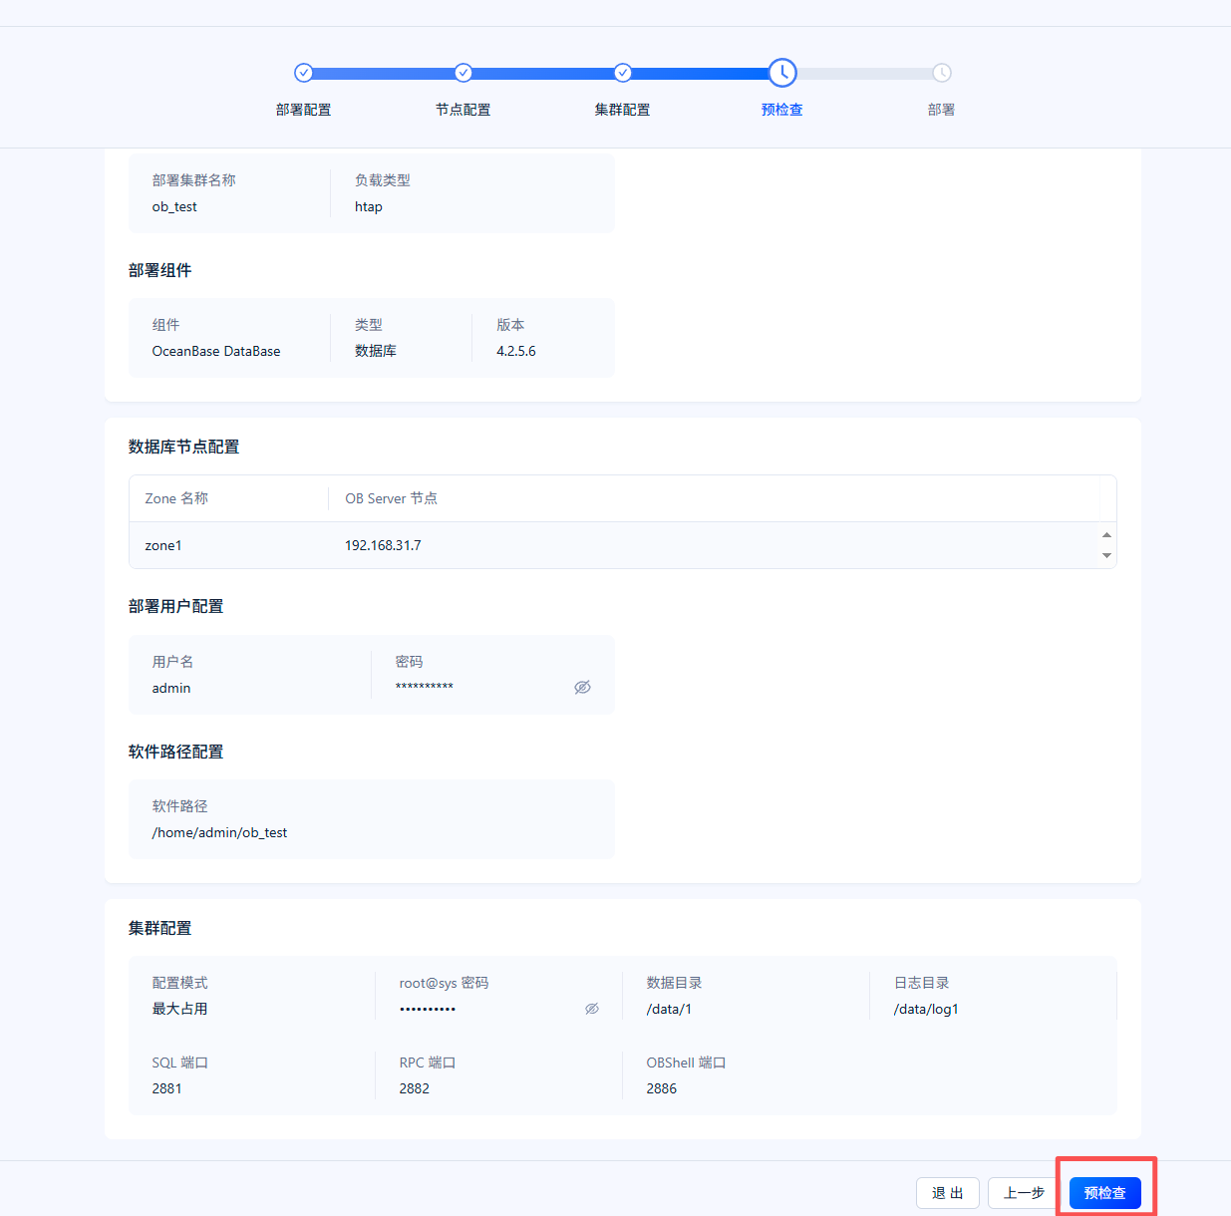

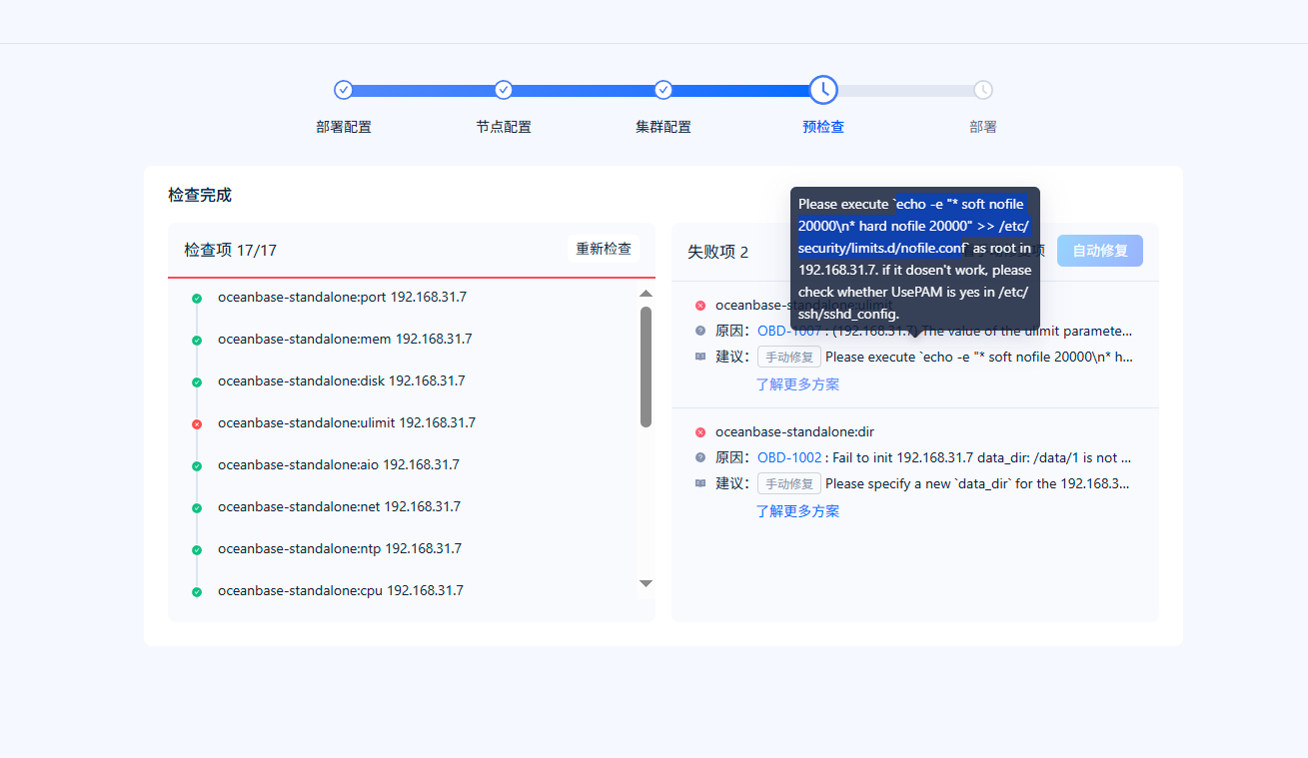
Root下执行手工修复语句并确认UsePAM是不是yes
[root@ob ~]# echo -e "* soft nofile 200000\n* hard nofile 200000" >> /etc/security/limits.d/nofile.conf
[root@ob ~]# more /etc/ssh/sshd_config |grep UsePAM
# WARNING: 'UsePAM no' is not supported in kylin and may cause several
UsePAM yes

第二个手工修改的是/data/1 /datalog1目录不是非空，进去把lost+found空目录删除

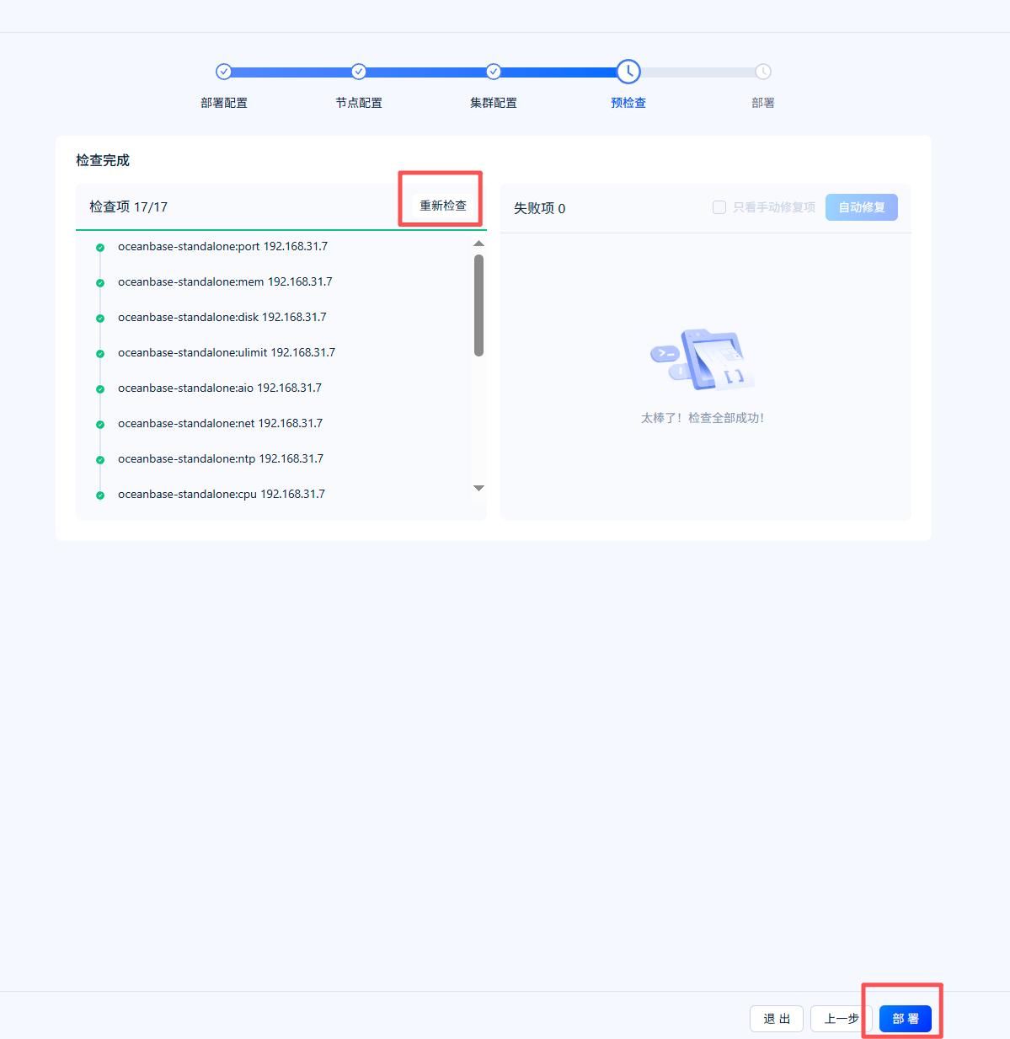
重新检查后，没问题点击部署

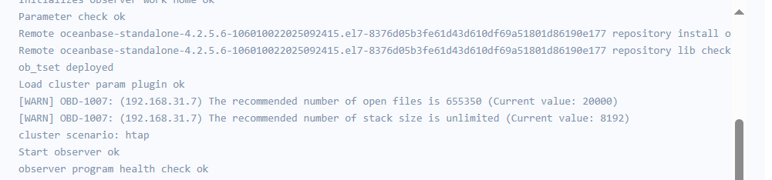
检查告警信息，对应修改/etc/security/limits.conf文件
* soft nofile 65535
* hard nofile 65535
* soft stack unlimited
* hard stack unlimited

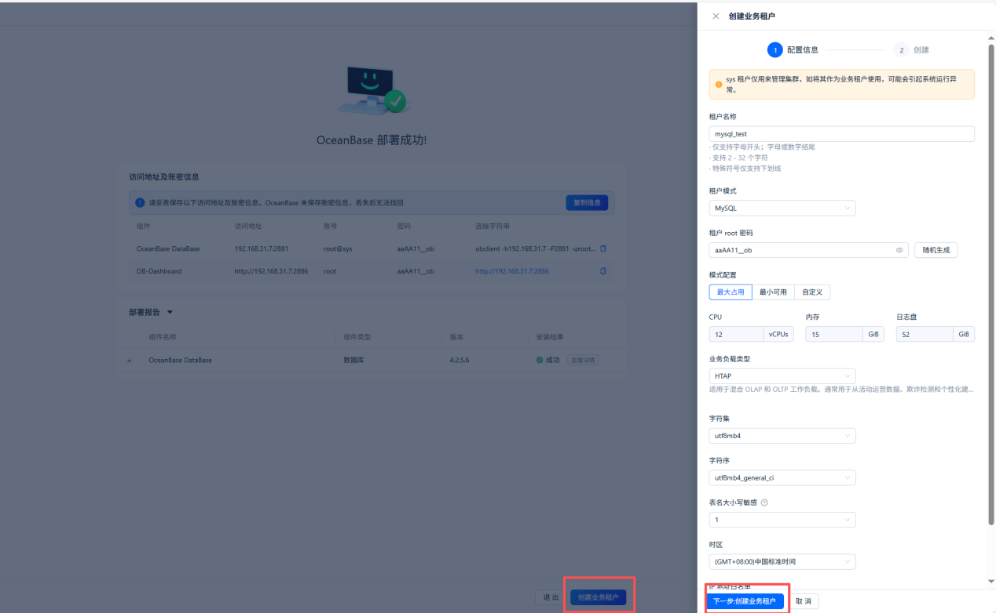
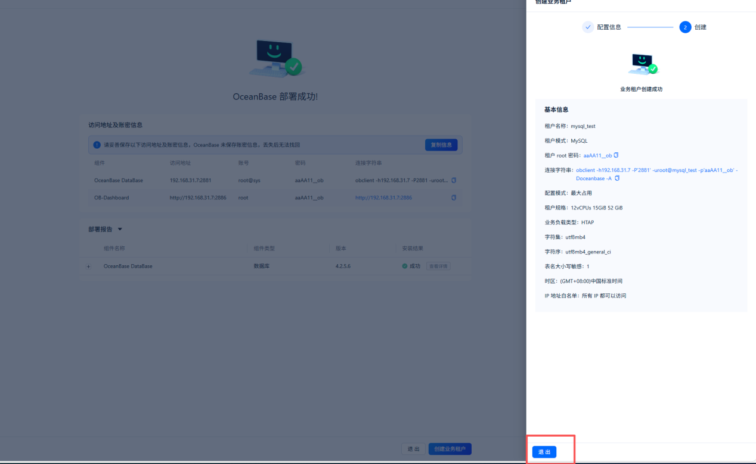

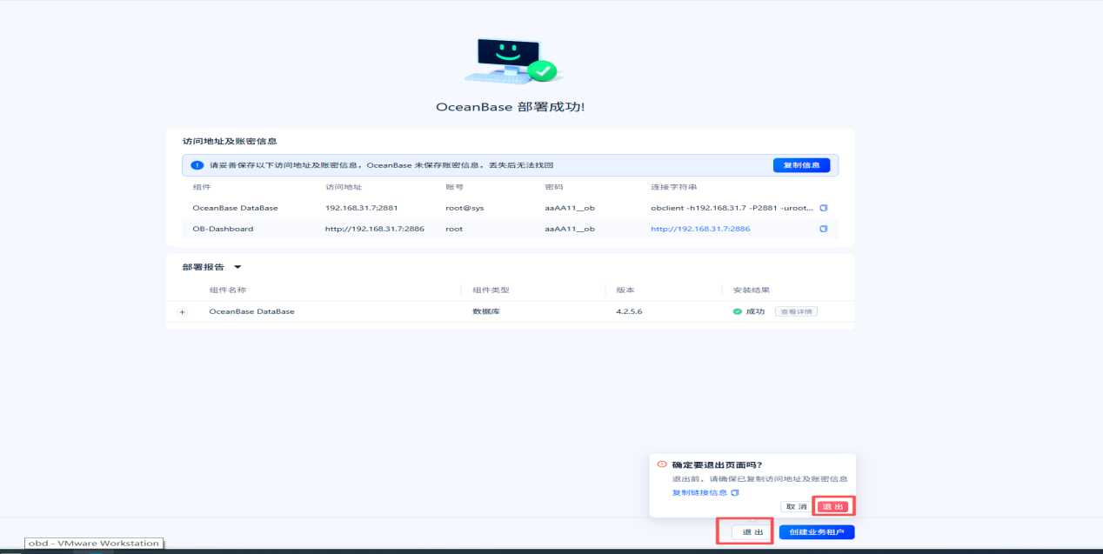

退出后进入192.168.31.7:2886云平台管理
调整集群参数
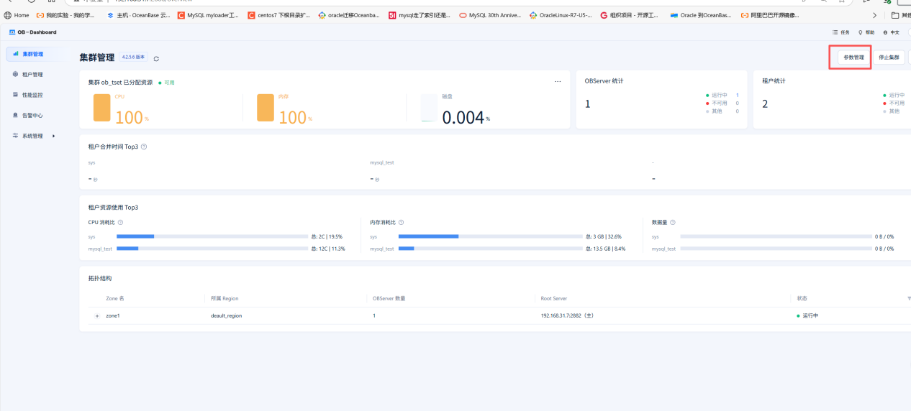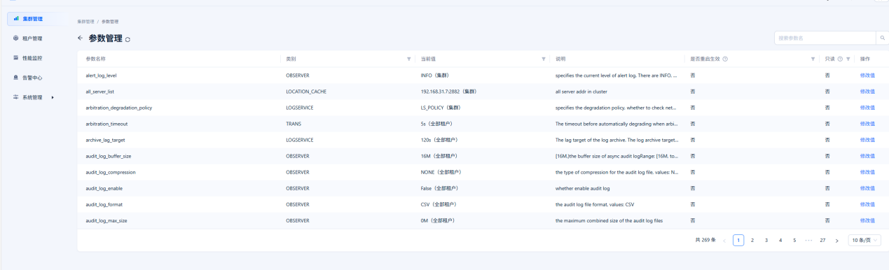
参数名称 | 默认值 | 推荐值 | 描述 | 是否重启 OBServer 节点生效
server_permanent_offline_time | 3600s | 86400s | 用于设置节点心跳中断的时间阈值，即节点心跳中断多久后认为其被永久下线，永久下线的节点上的数据副本需要被自动补足。 | 否
recyclebin_object_expire_time | 0s | 7d | 用于自动 Purge 回收站中过期的 Schema对象 | 否
memstore_limit_percentage | 0 | 50 | 用于设置租户使用 MemStore 的内存占其总可用内存的百分比 | 否
memory_limit_percentage | 80 | 90 | 用于设置 OBServer 总可用内存大小占总内存大小的百分比 | 否
max_syslog_file_count | 0 | 300 | 用于设置在回收日志文件之前可以容纳的日志文件数量 | 否
enable_syslog_recycle | FALSE | TRUE | 用于设置是否打开记录 OBServer 节点启动前的旧日志的开关。与 max_syslog_file_count 配合使用，决定回收逻辑是否考虑旧的日志文件 | 否
clog_sync_time_warn_threshold | 100ms | 1s | 用于设置事务日志同步耗时告警阈值，同步耗时超过该值产生 WARN 日志 | 否
balancer_task_timeout | 20m | 60m | 用于设置负载均衡等后台任务的超时时间 | 否
autoinc_cache_refresh_interval | 3600s | 43200s | 用于设置自增列缓存的刷新间隔 | 否
large_query_threshold | 5s | 600s | 用于设置查询执行时间的阈值。超过时间的请求可能被暂停，暂停后自动被判断为大查询，执行大查询调度策略 | 否
调整租户参数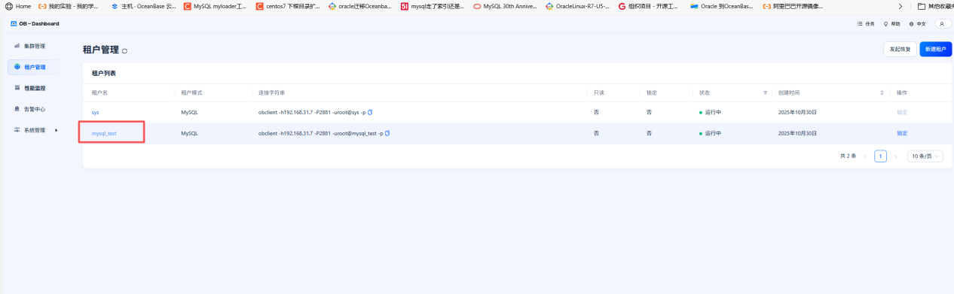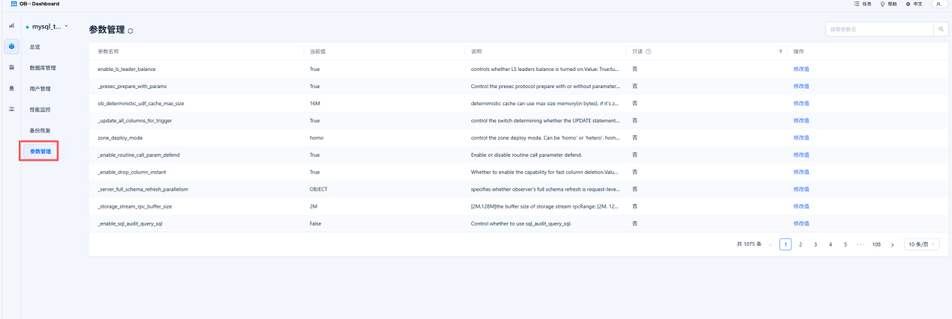
参数名称 | 默认值 | 推荐值 | 描述 | 是否重启 OBServer 节点生效
partition_balance_schedule_interval | 2h | 12h | 用于分区均衡调度周期 | 否
freeze_trigger_percentage | 20 | 50 | 用于设置触发冻结的租户使用 MemStore 内存的阈值百分比 | 否
major_compact_trigge | 0 | 500 | 用于设置多少次转储触发一次全局合并 | 否
writing_throttling_trigger_percentage | 60 | 90 | 用于设置写入速度的阈值 | 否
undo_retention | 1800 | 3600 | 用于设置系统应保留的多版本数据范围，在转储时控制多版本数据的回收，单位秒 | 否
open_cursors | 50 | 3000 | 用于限制单个 Session 可以同时打开的游标数量 | 否
ob_trx_idle_timeout | 86400000000 | 86400000000 | 用于设置事务超时时间，单位为微秒 | 否
ob_trx_idle_timeout | 86400000000 | 3600000000 | 用于设置事务空闲超时时间，即事务中两条语句之间的执行间隔超过该值时超时，单位微秒 | 否
ob_sql_work_area_percentage | 5 | 20 | 用于设置 SQL 工作区内存占整个租户内存百分比 | 否
ob_sql_audit_percentage | 3 | 10 | 用于设置 SQL Audit 内存上限占当前租户内存的百分比 | 否
ob_query_timeout | 10000000 | 3600000000 | 用于设置 SQL 最大执行时间，单位微秒 | 否
ob_enable_batched_multi_statement | FALSE | TRUE | 用于设置是否启用批处理功能的成组执行优化 | 否
max_allowed_packet | 16777216 | 100663296 | 用于设置最大网络包的大小 | 否
log_transport_compress_all | FALSE | TRUE | 用于对日志传输是否使用压缩 | 否
ob_plan_cache_percentage | 5 | 10 | 用于设置计划缓存可使用内存占租户内存的百分比 | 否

