3：配置hosts
# vi /etc/hosts
192.168.31.7 ob
192.168.31.8 oms

4：关闭防火墙
systemctl disable firewalld
systemctl stop firewalld
systemctl status firewalld
5：关闭SElinux
vi /etc/selinux/config
SELINUX=disabled
6：查看透明大页是否关闭
cat /sys/kernel/mm/transparent_hugepage/enabled
echo never > /sys/kernel/mm/transparent_hugepage/enabled
#先分区后创建用户
####挂载oms机器
mkdir /data/oms
pvcreate /dev/sdb
vgcreate vg_ob /dev/sdb
lvcreate -L300G -n home vg_ob
lvcreate -L600G -n oms vg_ob
lvcreate -L200G -n docker vg_ob

mkfs.ext4 /dev/mapper/vg_ob-home
mkfs.ext4 /dev/mapper/vg_ob-oms

[root@danoms kylin]#blkid
/dev/mapper/vg_ob-home: UUID="499bb32b-81ab-4ea4-87f7-4101a98577c9" BLOCK_SIZE="4096" TYPE="ext4"
/dev/mapper/vg_ob-oms: UUID="0eea3025-ad50-437f-bc71-839493b358cb" BLOCK_SIZE="4096" TYPE="ext4"

[root@danoms kylin]# vi /etc/fstab
UUID=499bb32b-81ab-4ea4-87f7-4101a98577c9 /home ext4 defaults,noatime,nodiratime,barrier=0 0 0
UUID=0eea3025-ad50-437f-bc71-839493b358cb /data/oms ext4 defaults,noatime,nodiratime,barrier=0 0 0

[root@danoms kylin]# mount -a
[root@danoms kylin]# df -h

3：创建admin用户并对目录赋权
groupadd -g 500 admin
useradd -u 500 -g admin admin
chown admin:admin -R /home
chown admin:admin -R /data
passwd admin

4：修好内核参数
# vi /etc/sysctl.conf
net.core.somaxconn = 2048
net.core.netdev_max_backlog = 10000
net.core.rmem_default = 16777216
net.core.wmem_default = 16777216
net.core.rmem_max = 16777216
net.core.wmem_max = 16777216

net.ipv4.ip_local_port_range = 3500 65535
net.ipv4.ip_forward = 0
net.ipv4.conf.default.rp_filter = 1
net.ipv4.conf.default.accept_source_route = 0
net.ipv4.tcp_syncookies = 0
net.ipv4.tcp_rmem = 4096 87380 16777216
net.ipv4.tcp_wmem = 4096 65536 16777216
net.ipv4.tcp_max_syn_backlog = 16384
net.ipv4.tcp_fin_timeout = 15
net.ipv4.tcp_max_syn_backlog = 16384
net.ipv4.tcp_tw_reuse = 1
net.ipv4.tcp_slow_start_after_idle=0
net.ipv4.ip_local_reserved_ports = 62881-63881

vm.swappiness = 0
vm.min_free_kbytes = 2097152
vm.overcommit_memory = 0

fs.aio-max-nr=1048576
vm.max_map_count=655360
vm.nr_hugepages = 0
# sysctl -p

Root下执行手工修复语句并确认UsePAM是不是yes
[root@ob ~]# echo -e "* soft nofile 200000\n* hard nofile 200000" >> /etc/security/limits.d/nofile.conf
[root@ob ~]# more /etc/ssh/sshd_config |grep UsePAM
# WARNING: 'UsePAM no' is not supported in kylin and may cause several
UsePAM yes

检查告警信息，对应修改/etc/security/limits.conf文件
* soft nofile 65535
* hard nofile 65535
* soft stack unlimited
* hard stack unlimited

上传软件包
docker-27.5.1.tgz
oms-4.3.0_x86_all_in_one-amd64-28202505301359.tar

[root@ob home]# tar -xvf docker-27.5.1.tgz
docker/
docker/runc
docker/containerd
docker/docker-init
docker/dockerd
docker/containerd-shim-runc-v2
docker/docker-proxy
docker/docker
docker/ctr
[root@ob home]#cp /home/docker/* /usr/bin/
[root@ob home]# vi /etc/systemd/system/docker.service
[Unit]
Description=Docker Application Container Engine
Documentation=https://docs.docker.com
After=network-online.target firewalld.service
Wants=network-online.target

[Service]
Type=notify
ExecStart=/usr/bin/dockerd
ExecReload=/bin/kill -s HUP $MAINPID
LimitNOFILE=infinity
LimitNPROC=infinity
TimeoutStartSec=0
Delegate=yes
KillMode=process
Restart=on-failure
StartLimitBurst=3
StartLimitInterval=60s

[Install]
WantedBy=multi-user.target
[root@ob docker]# chmod +x /etc/systemd/system/docker.service

[root@ob docker]# systemctl start docker
[root@ob docker]# systemctl enable docker
[root@ob docker]# systemctl status docker
[root@ob home]# docker -v
Docker version 27.5.1, build 9f9e405

[root@ob ~]# docker load -i oms-4.3.0_x86_all_in_one-amd64-28202505301359.tar
174f56854903: Loading layer [==================================================>] 211.7MB/211.7MB
fa06ce3041a5: Loading layer [==================================================>] 390.1kB/390.1kB
47aa494845ab: Loading layer [==================================================>] 10.24kB/10.24kB
b64af7077518: Loading layer [==================================================>] 3.072kB/3.072kB
dbc7883442d2: Loading layer [==================================================>] 48.13kB/48.13kB
10037aa1a584: Loading layer [==================================================>] 6.656kB/6.656kB
a082cc6446df: Loading layer [==================================================>] 4.096kB/4.096kB
19f2f7fd6cbc: Loading layer [==================================================>] 711.7kB/711.7kB
53143ea0a5fd: Loading layer [==================================================>] 3.072kB/3.072kB
a083f5a0804b: Loading layer [==================================================>] 39.94kB/39.94kB
3f258215a2f0: Loading layer [==================================================>] 8.704kB/8.704kB
a064541292ca: Loading layer [==================================================>] 9.728kB/9.728kB
45eed0cfcea9: Loading layer [==================================================>] 525.5MB/525.5MB
22979d959736: Loading layer [==================================================>] 5.632kB/5.632kB
3a1f3a965212: Loading layer [==================================================>] 36.32MB/36.32MB
b7fe7e8bb8af: Loading layer [==================================================>] 3.072kB/3.072kB
19697a0864b6: Loading layer [==================================================>] 798.2kB/798.2kB
836ddd98b178: Loading layer [==================================================>] 58.24MB/58.24MB
b532efbb57d2: Loading layer [==================================================>] 3.072kB/3.072kB
106ea40d6279: Loading layer [==================================================>] 3.584kB/3.584kB
8e5388168272: Loading layer [==================================================>] 7.43GB/7.43GB
49534242838f: Loading layer [==================================================>] 15.87kB/15.87kB
2707f59ab768: Loading layer [==================================================>] 552.6MB/552.6MB
9e0ba9bb09f4: Loading layer [==================================================>] 4.608kB/4.608kB
861c2940bc7b: Loading layer [==================================================>] 1.546MB/1.546MB
608072133189: Loading layer [==================================================>] 173.7MB/173.7MB
f7c12e6016f9: Loading layer [==================================================>] 3.584kB/3.584kB
8321b8e7d4fd: Loading layer [==================================================>] 1.703MB/1.703MB
5f70bf18a086: Loading layer [==================================================>] 1.024kB/1.024kB
ea2aa97825f3: Loading layer [==================================================>] 88.5MB/88.5MB
be68ef93b8c8: Loading layer [==================================================>] 91.89MB/91.89MB
98d2dce1ba49: Loading layer [==================================================>] 105.5kB/105.5kB
87973299b2a6: Loading layer [==================================================>] 69.01MB/69.01MB
Loaded image: harbor.oceanbase-dev.com/obartifact-temporary/amd64/oms/28202505301359/oms:4.3.0_x86_all_in_one

创建目录
mkdir -p /data/oms/data /data/oms/log
chown admin:admin -R /data

进入192.168.31.7机器，开启obd页面
su - admin
obd web

登录192.168.31.7:8680
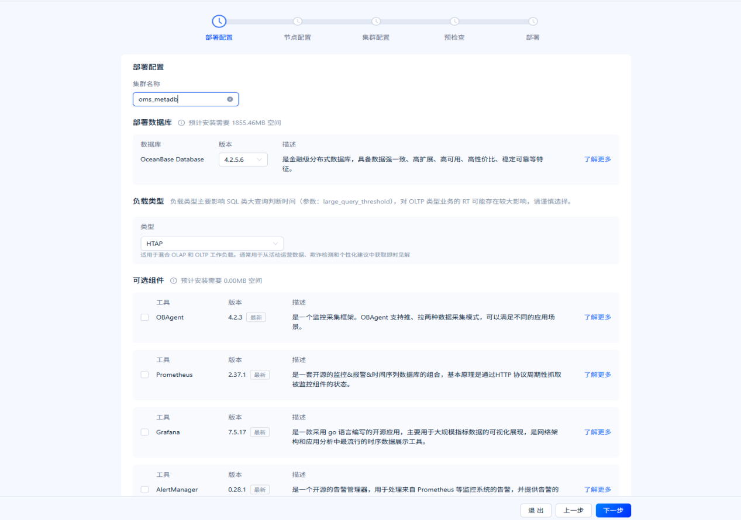
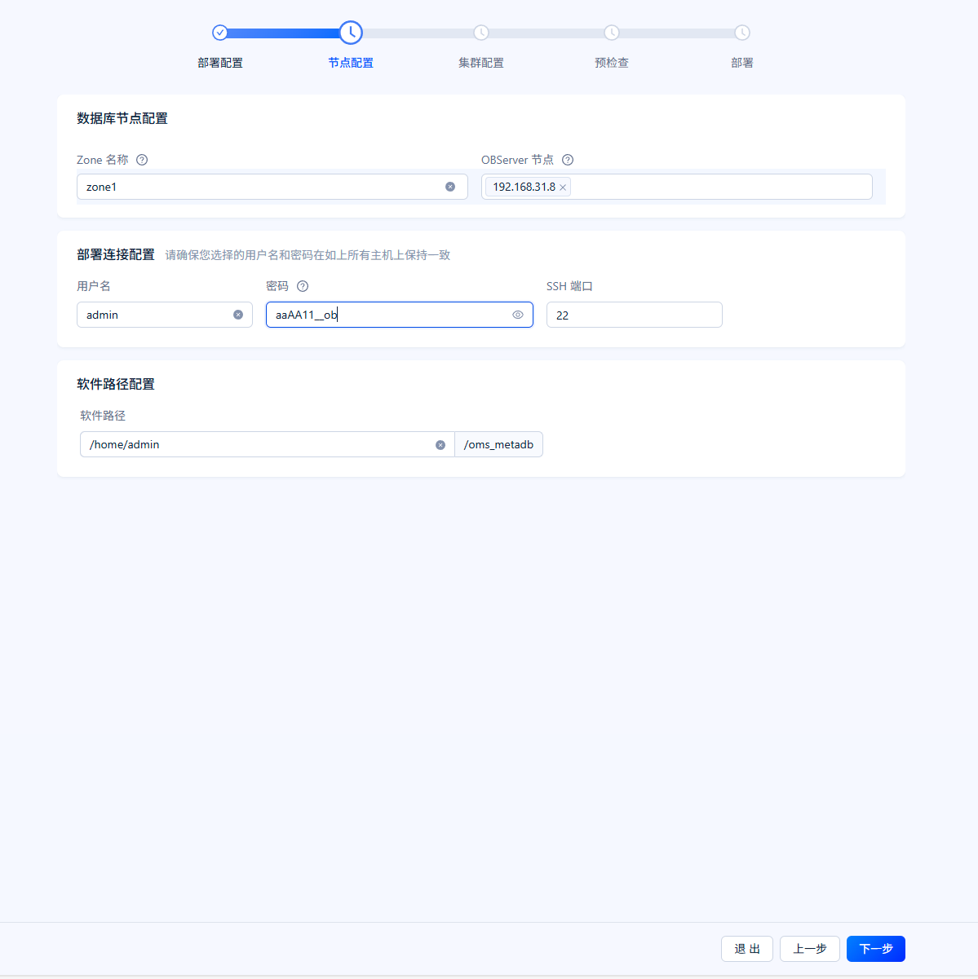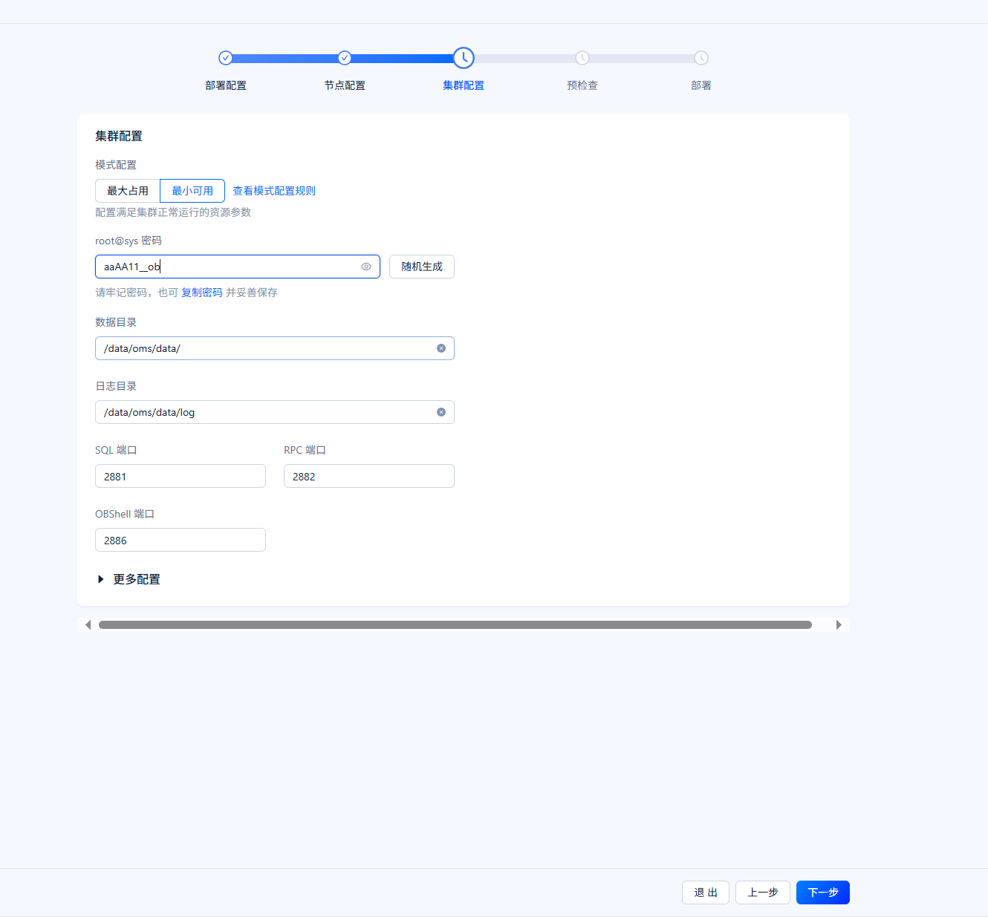
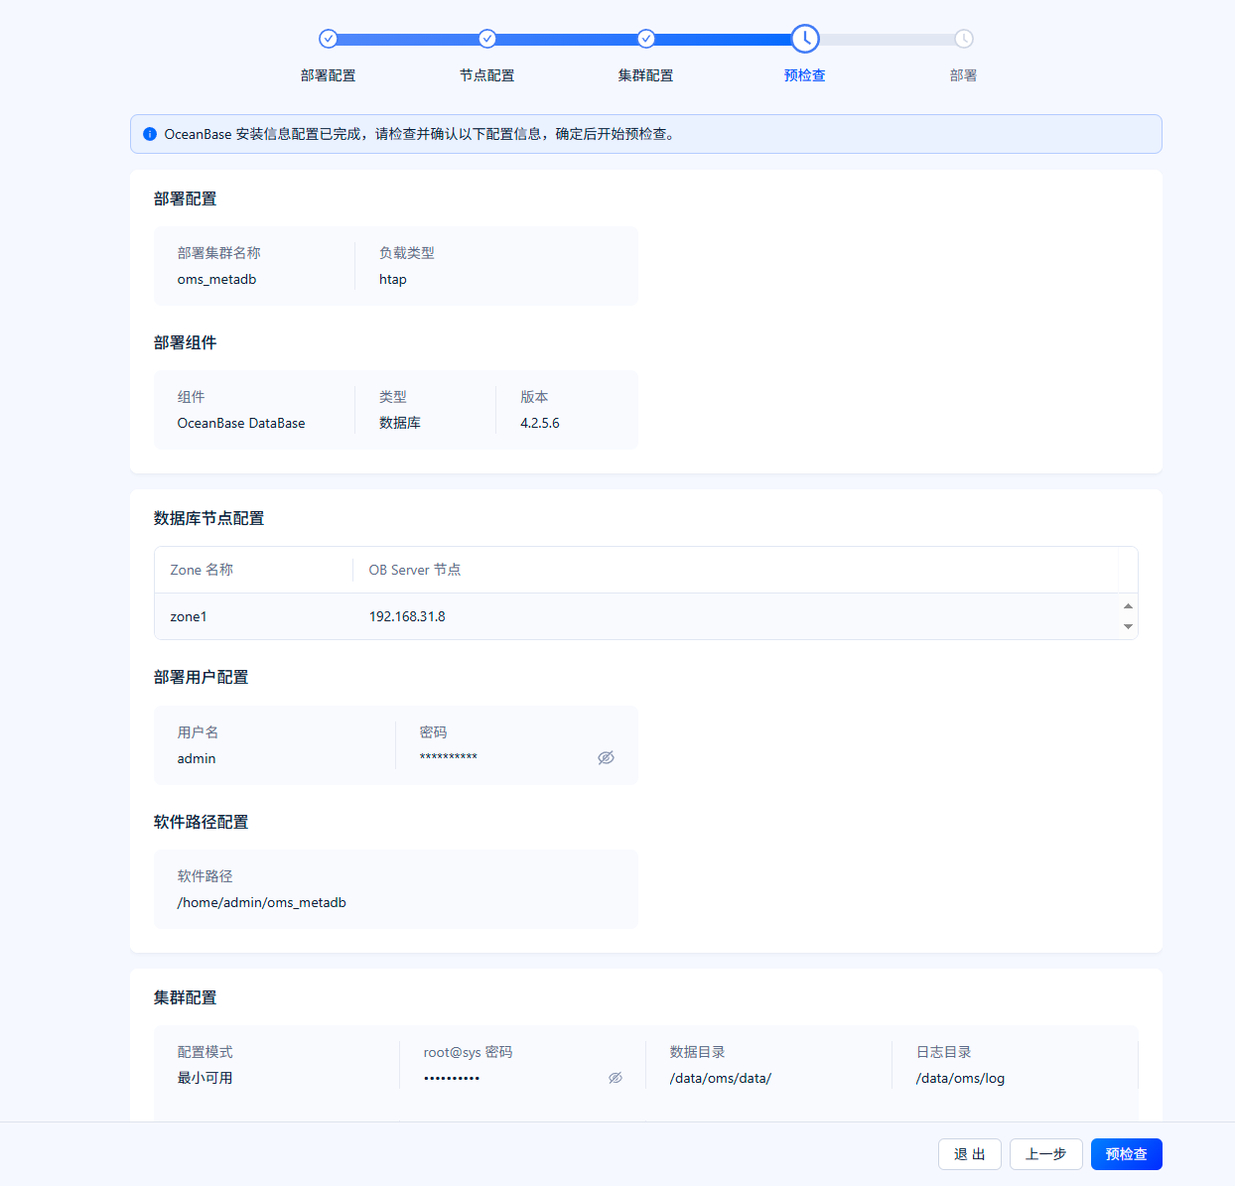
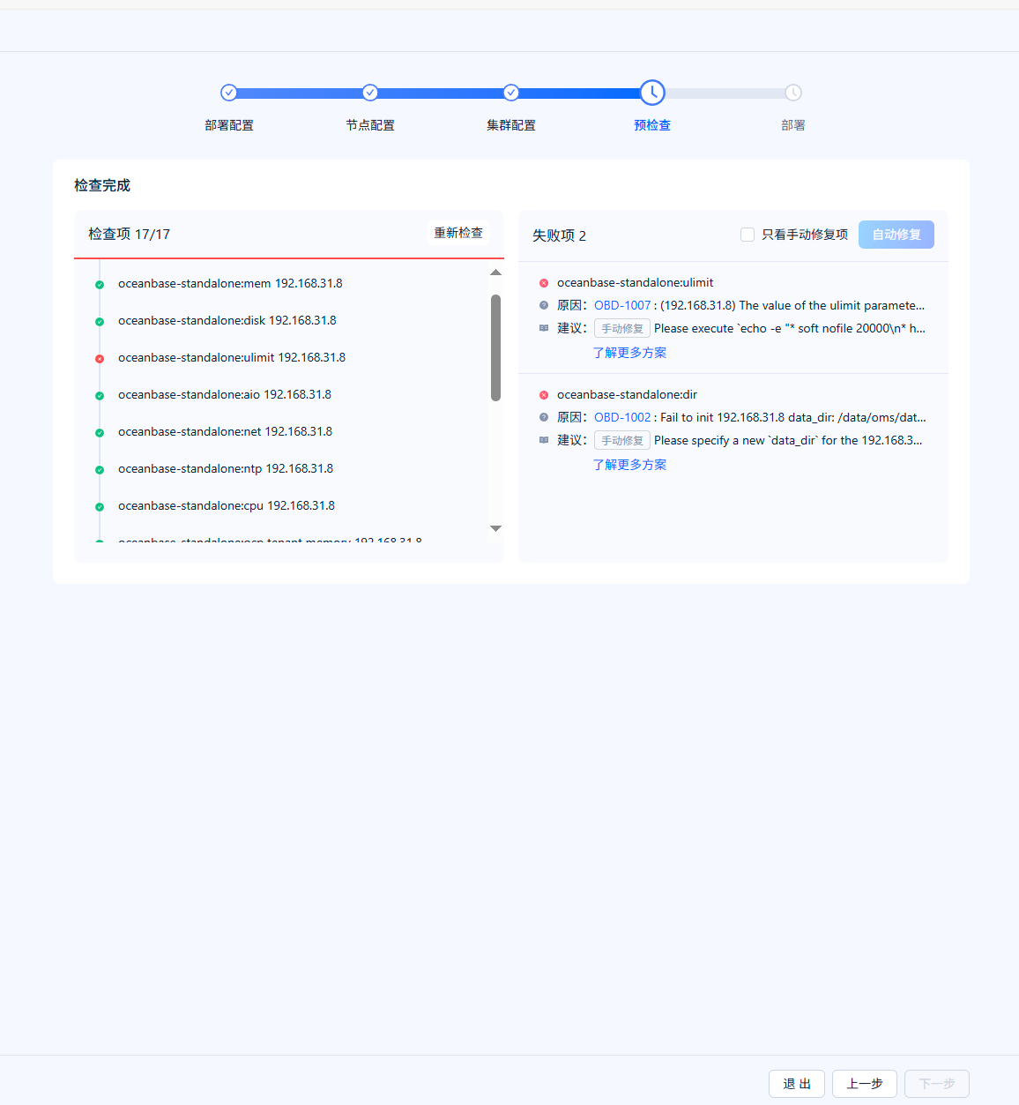
同ob集群安装一样的手工修复，修复成功点击部署
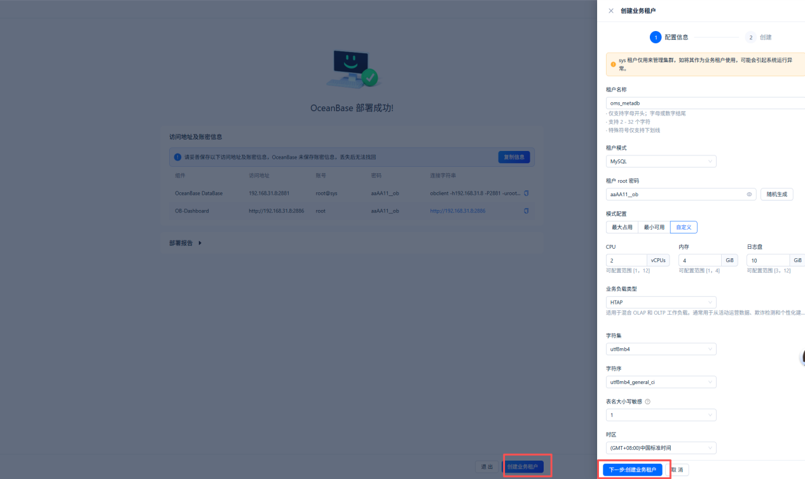
部署成功后，创建oms的mysql模式实例做元数据库，规格2c4g
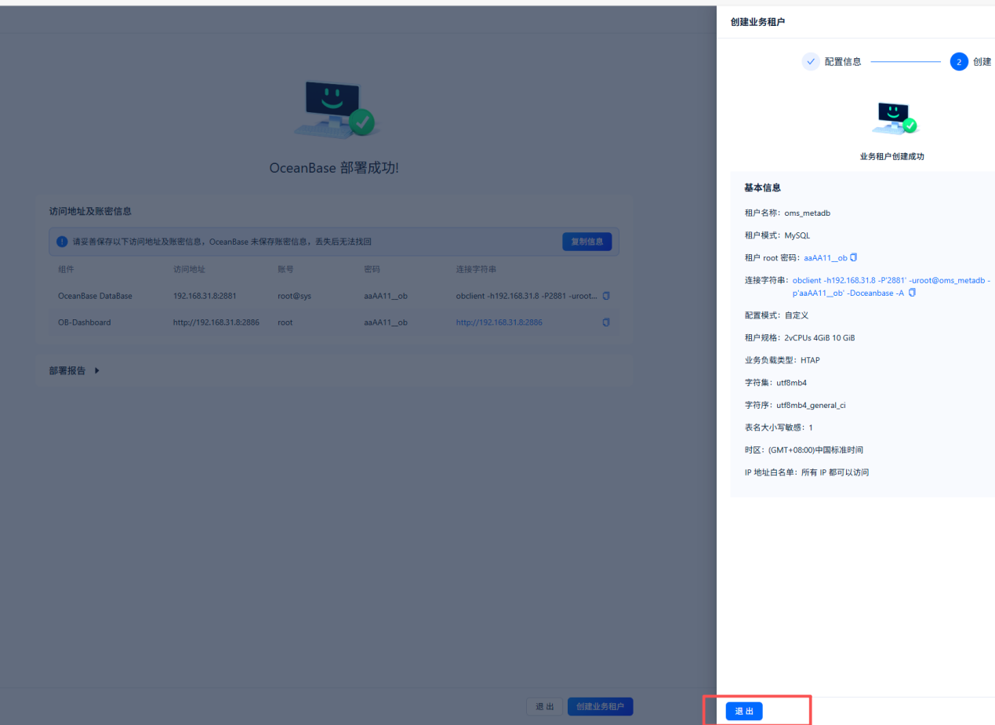
记住连接串obclient -h192.168.31.8 -P'2881' -uroot@oms_metadb -p'aaAA11__ob' -Doceanbase -A
创建好后回到192.168.31.8（oms机器）
[root@ob ~]# sudo docker images
REPOSITORY TAG IMAGE ID CREATED SIZE
harbor.oceanbase-dev.com/obartifact-temporary/amd64/oms/28202505301359/oms 4.3.0_x86_all_in_one 7db2c4d53a66 5 months ago 9.21GB

##格式如下：sudo docker run -d --net host --name oms-config-tool <OMS_IMAGE> bash && sudo docker cp oms-config-tool:/root/docker_remote_deploy.sh . && sudo docker rm -f oms-config-tool（<OMS_IMAGE> 是上文sudo docker images查到的信息）

[root@ob oms_metadb]# sudo docker run -d --net host --name oms-config-tool harbor.oceanbase-dev.com/obartifact-temporary/amd64/oms/28202505301359/oms:4.3.0_x86_all_in_one bash && sudo docker cp oms-config-tool:/root/docker_remote_deploy.sh . && sudo docker rm -f oms-config-tool
55edc56f23665e6fae8ca299fb896fc0ad02c66fa7a102d23008f9cf8c125583
Successfully copied 4.61kB to /home/admin/oms_metadb/.
oms-config-tool

##格式如下：sh docker_remote_deploy.sh -o <OMS 容器挂载目录> -i <本机 IP 地址> -d <OMS_IMAGE>
[root@ob oms_metadb]# sh docker_remote_deploy.sh -o /data/oms -i 172.17.208.25 -d harbor.oceanbase-dev.com/obartifact-temporary/amd64/oms/28202505301359/oms:4.3.0_x86_all_in_one
提示：输入 <Control-C> 可退出部署

请选择部署模式：
●单地域单节点
单地域多节点
多地域
您选择的部署模式是：单地域单节点部署模式
请选择您所需要进行的任务：
●无配置文件，全新部署 OMS，从生成配置文件开始
已通过脚本[-c]选项传入参考配置文件，基于参考配置文件开始配置
开始配置 RM 和 CM 的元信息库，可以是 MySQL 或 OceanBase 数据库 MySQL 租户
(元信息库用于存储 OMS 运行时元数据信息）
[y/n] RM 和 CM 库需要分开部署吗？（默认无需分开部署）[n]n
##oms ip
请输入元信息数据库 IP：192.168.31.8
请输入元信息数据库端口：2881
##填其他的会默认创建到sys租户下
请输入元信息数据库用户名：root@oms_metadb
##自己设置密码
请输入元信息数据库密码：**********
请为 OMS 元数据库设置前缀
（示例：当前缀设置为 oms 时，最终库名分别为 oms_rm/oms_cm/oms_cm_hb）：oms
您的元信息库配置如下：
{
"drc_cm_db": "oms_cm",
"drc_cm_heartbeat_db": "oms_cm_hb",
"drc_rm_db": "oms_rm",
"oms_cm_meta_host": "192.168.31.8",
"oms_cm_meta_password": "aaAA11__ob",
"oms_cm_meta_port": "2881",
"oms_cm_meta_user": "root@oms_metadb",
"oms_rm_meta_host": "192.168.31.8",
"oms_rm_meta_password": "aaAA11__ob",
"oms_rm_meta_port": "2881",
"oms_rm_meta_user": "root@oms_metadb"
}

[y/n] 请确认配置信息[y]y
您选择的部署模式为单地域单节点部署模式
[y/n] 获取到您的默认 IP 地址：192.168.31.8，请确认是否需要更改？[n]n
您的 OMS 集群配置如下：
{
"cm_location": 0,
"cm_nodes": [
"192.168.31.8"
],
"cm_region": "default",
"cm_region_cn": "默认地域",
"cm_url": "http://192.168.31.8:8088"
}

[y/n] 请确认配置信息[y]y
[y/n] 您是否需要对 OMS 历史数据进行监控？[n]n
[y/n] 是否需要开启 OMS 审计日志功能，并将审计日志写入 SLS 服务？[n]n
已加载您的所有配置项，并校验通过。
您的配置如下：
{
"apsara_audit_enable": "false",
"apsara_audit_sls_access_key": "",
"apsara_audit_sls_access_secret": "",
"apsara_audit_sls_endpoint": "",
"apsara_audit_sls_ops_site_topic": "",
"apsara_audit_sls_user_site_topic": "",
"cm_location": "0",
"cm_nodes": [
"192.168.31.8"
],
"cm_region": "default",
"cm_region_cn": "默认地域",
"cm_url": "http://192.168.31.8:8088",
"drc_cm_db": "oms_cm",
"drc_cm_heartbeat_db": "oms_cm_hb",
"drc_rm_db": "oms_rm",
"oms_cm_meta_host": "192.168.31.8",
"oms_cm_meta_password": "aaAA11__ob",
"oms_cm_meta_port": "2881",
"oms_cm_meta_user": "root",
"oms_rm_meta_host": "192.168.31.8",
"oms_rm_meta_password": "aaAA11__ob",
"oms_rm_meta_port": "2881",
"oms_rm_meta_user": "root@oms_metadb",
"tsdb_enabled": "false",
"tsdb_password": "",
"tsdb_service": "",
"tsdb_url": "",
"tsdb_username": ""
}

[y/n] 您是否需要重新配置？[n]n
您是需要在当前执行的机器上
接下来 OMS 需要在节点 ['192.168.31.8'] 上依次执行部署脚本。
请输入节点 192.168.31.8 上预备部署 OMS 的挂载目录：[/data/oms/]/data/oms/
请您确认以下内容：
[y/n] 部署 OMS 的 [镜像名/IMAGE-ID] 是：harbor.oceanbase-dev.com/obartifact-temporary/amd64/oms/28202505301359/oms:4.3.0_x86_all_in_one ，请确认是否正确。[y]y
[y/n] 是否需要在 OMS 容器中挂载 HTTPS 证书？[n]n
[y/n] 192.168.31.8 节点下的配置文件 config.yaml 将写在这个路径：/data/oms/ 下可以吗？[y]y

04a1aeff69f86b05b1b27ad3fa94b31141ec8407279b1b3a5037ff574019751d
Waiting docker_cmd.sh to finished
convert config.yaml if necessary start...
start docker config upgrade....

"apsara_audit_enable": "false"
"apsara_audit_sls_access_key": ""
"apsara_audit_sls_access_secret": ""
"apsara_audit_sls_endpoint": ""
"apsara_audit_sls_ops_site_topic": ""
"apsara_audit_sls_user_site_topic": ""
"cm_location": "0"
"cm_nodes":
- "192.168.31.8"
"cm_region": "default"
"cm_region_cn": "默认地域"
"cm_url": "http://192.168.31.8:8088"
"drc_cm_db": "oms_cm"
"drc_cm_heartbeat_db": "oms_cm_hb"
"drc_rm_db": "oms_rm"
"oms_cm_meta_host": "192.168.31.8"
"oms_cm_meta_password": "aaAA11__ob"
"oms_cm_meta_port": "2881"
"oms_cm_meta_user": "root"
"oms_rm_meta_host": "192.168.31.8"
"oms_rm_meta_password": "aaAA11__ob"
"oms_rm_meta_port": "2881"
"oms_rm_meta_user": "root"
"tsdb_enabled": "false"
"tsdb_password": ""
"tsdb_service": ""
"tsdb_url": ""
"tsdb_username": ""

'oms_meta_host' not found in /home/admin/conf/config.yaml
convert config.yaml end...
[CHECK] Check the validity of config.yaml format.
[PASSED]
[CHECK] Check the version of Docker on the host machine.
Docker version is: 27.5.1.
[PASSED]
[CHECK] Check the synchronization between the MetaDB clock and the machine clock.
[PASSED]

--------------------------------------------------------------------------------
# 【步骤一】校验 config.yaml 配置文件
--------------------------------------------------------------------------------
python -m omsflow.scripts.units.oms_cluster_config --check /home/admin/conf/config.yaml

/root/omsflow
2025-10-30 19:23:28,797-Oms-DEBUG oms_cluster_config.main.922 :load config file /home/admin/conf/config.yaml
`master_cm_endpoint` is http://192.168.31.8:8088

`master_oms_endpoint` is http://192.168.31.8:8082

`role` is master

success: config file is verification ok ...

master_drc_rm_meta_uri is accessible

master_drc_cm_meta_uri is accessible

cm_location is 0

--------------------------------------------------------------------------------
# 【步骤二】创建 OMS 元信息库
--------------------------------------------------------------------------------
python -m omsflow.scripts.units.oms_init_manager --init-db

/root/omsflow
use config /home/admin/conf/config.yaml

no drop task

no init task

query {'charset': 'utf8'} {'username': 'root', 'database': 'oms_cm', 'host': '192.168.31.8', 'password_original': 'aaAA11__ob', 'drivername': 'mysql+pymysql', 'query': {'charset': 'utf8'}, 'port': 2881}
2025-10-30 19:23:29,480-Oms-DEBUG units.create_engine_wrapper.70 :create a new sqlalchemy engine wrapped Engine(mysql+pymysql://root:***@192.168.31.8:2881/oms_cm?charset=utf8)
query {'charset': 'utf8'} {'username': 'root', 'database': 'oms_rm', 'host': '192.168.31.8', 'password_original': 'aaAA11__ob', 'drivername': 'mysql+pymysql', 'query': {'charset': 'utf8'}, 'port': 2881}
2025-10-30 19:23:29,616-Oms-DEBUG units.create_engine_wrapper.70 :create a new sqlalchemy engine wrapped Engine(mysql+pymysql://root:***@192.168.31.8:2881/oms_rm?charset=utf8)
query {'charset': 'utf8'} {'username': 'root', 'database': 'oms_cm_hb', 'host': '192.168.31.8', 'password_original': 'aaAA11__ob', 'drivername': 'mysql+pymysql', 'query': {'charset': 'utf8'}, 'port': 2881}
2025-10-30 19:23:29,734-Oms-DEBUG units.create_engine_wrapper.70 :create a new sqlalchemy engine wrapped Engine(mysql+pymysql://root:***@192.168.31.8:2881/oms_cm_hb?charset=utf8)
query {'charset': 'utf8'} {'username': 'root', 'database': 'oms_rm', 'host': '192.168.31.8', 'password_original': 'aaAA11__ob', 'drivername': 'mysql+pymysql', 'query': {'charset': 'utf8'}, 'port': 2881}
2025-10-30 19:23:29,866-Oms-DEBUG units.create_engine_wrapper.70 :create a new sqlalchemy engine wrapped Engine(mysql+pymysql://root:***@192.168.31.8:2881/oms_rm?charset=utf8)
2025-10-30 19:23:29,912-Oms-DEBUG oms_init_manager._import_sql_file_by_engine.68 :Engine(mysql+pymysql://root:***@192.168.31.8:2881/oms_rm?charset=utf8)
import /root/omsflow/meta_init/drc_rm_schema.sql

mysql -h'192.168.31.8' -P2881 -u 'root' --password='aaAA11__ob' -f -D 'oms_rm' < /root/omsflow/meta_init/drc_rm_schema.sql
...
...
...

2025-10-30 19:27:42,737-urllib3.connectionpool-DEBUG connectionpool._new_conn.250 :Starting new HTTP connection (1): 192.168.31.8:8088
2025-10-30 19:27:42,771-urllib3.connectionpool-DEBUG connectionpool._make_request.484 :http://192.168.31.8:8088 "POST /resource/host/tag/add HTTP/1.1" 200 1604
{"data":[{"gmtCreate":1761823662000,"gmtModified":1761823662000,"id":1,"ip":"192.168.31.8","status":0,"tagId":3},{"gmtCreate":1761823662000,"gmtModified":1761823662000,"id":2,"ip":"192.168.31.8","status":0,"tagId":2},{"gmtCreate":1761823662000,"gmtModified":1761823662000,"id":3,"ip":"192.168.31.8","status":0,"tagId":4},{"gmtCreate":1761823662000,"gmtModified":1761823662000,"id":4,"ip":"192.168.31.8","status":0,"tagId":9},{"gmtCreate":1761823662000,"gmtModified":1761823662000,"id":5,"ip":"192.168.31.8","status":0,"tagId":10},{"gmtCreate":1761823662000,"gmtModified":1761823662000,"id":6,"ip":"192.168.31.8","status":0,"tagId":29},{"gmtCreate":1761823662000,"gmtModified":1761823662000,"id":7,"ip":"192.168.31.8","status":0,"tagId":28},{"gmtCreate":1761823662000,"gmtModified":1761823662000,"id":8,"ip":"192.168.31.8","status":0,"tagId":30},{"gmtCreate":1761823662000,"gmtModified":1761823662000,"id":9,"ip":"192.168.31.8","status":0,"tagId":20},{"gmtCreate":1761823662000,"gmtModified":1761823662000,"id":10,"ip":"192.168.31.8","status":0,"tagId":23},{"gmtCreate":1761823662000,"gmtModified":1761823662000,"id":11,"ip":"192.168.31.8","status":0,"tagId":24},{"gmtCreate":1761823662000,"gmtModified":1761823662000,"id":12,"ip":"192.168.31.8","status":0,"tagId":27},{"gmtCreate":1761823662000,"gmtModified":1761823662000,"id":13,"ip":"192.168.31.8","status":0,"tagId":25},{"gmtCreate":1761823662000,"gmtModified":1761823662000,"id":14,"ip":"192.168.31.8","status":0,"tagId":26},{"gmtCreate":1761823662000,"gmtModified":1761823662000,"id":15,"ip":"192.168.31.8","status":0,"tagId":12}],"isSuccess":true}

add connector tag store_to_dataflow_sink to 192.168.31.8

2025-10-30 19:27:42,775-urllib3.connectionpool-DEBUG connectionpool._new_conn.250 :Starting new HTTP connection (1): 192.168.31.8:8088
2025-10-30 19:27:42,812-urllib3.connectionpool-DEBUG connectionpool._make_request.484 :http://192.168.31.8:8088 "POST /resource/host/tag/add HTTP/1.1" 200 1710
{"data":[{"gmtCreate":1761823662000,"gmtModified":1761823662000,"id":1,"ip":"192.168.31.8","status":0,"tagId":3},{"gmtCreate":1761823662000,"gmtModified":1761823662000,"id":2,"ip":"192.168.31.8","status":0,"tagId":2},{"gmtCreate":1761823662000,"gmtModified":1761823662000,"id":3,"ip":"192.168.31.8","status":0,"tagId":4},{"gmtCreate":1761823662000,"gmtModified":1761823662000,"id":4,"ip":"192.168.31.8","status":0,"tagId":9},{"gmtCreate":1761823662000,"gmtModified":1761823662000,"id":5,"ip":"192.168.31.8","status":0,"tagId":10},{"gmtCreate":1761823662000,"gmtModified":1761823662000,"id":6,"ip":"192.168.31.8","status":0,"tagId":29},{"gmtCreate":1761823662000,"gmtModified":1761823662000,"id":7,"ip":"192.168.31.8","status":0,"tagId":28},{"gmtCreate":1761823662000,"gmtModified":1761823662000,"id":8,"ip":"192.168.31.8","status":0,"tagId":30},{"gmtCreate":1761823662000,"gmtModified":1761823662000,"id":9,"ip":"192.168.31.8","status":0,"tagId":20},{"gmtCreate":1761823662000,"gmtModified":1761823662000,"id":10,"ip":"192.168.31.8","status":0,"tagId":23},{"gmtCreate":1761823662000,"gmtModified":1761823662000,"id":11,"ip":"192.168.31.8","status":0,"tagId":24},{"gmtCreate":1761823662000,"gmtModified":1761823662000,"id":12,"ip":"192.168.31.8","status":0,"tagId":27},{"gmtCreate":1761823662000,"gmtModified":1761823662000,"id":13,"ip":"192.168.31.8","status":0,"tagId":25},{"gmtCreate":1761823662000,"gmtModified":1761823662000,"id":14,"ip":"192.168.31.8","status":0,"tagId":26},{"gmtCreate":1761823662000,"gmtModified":1761823662000,"id":15,"ip":"192.168.31.8","status":0,"tagId":12},{"gmtCreate":1761823662000,"gmtModified":1761823662000,"id":16,"ip":"192.168.31.8","status":0,"tagId":14}],"isSuccess":true}

add connector tag store_to_kafka_sink to 192.168.31.8

2025-10-30 19:27:42,816-urllib3.connectionpool-DEBUG connectionpool._new_conn.250 :Starting new HTTP connection (1): 192.168.31.8:8088
2025-10-30 19:27:42,843-urllib3.connectionpool-DEBUG connectionpool._make_request.484 :http://192.168.31.8:8088 "POST /resource/host/tag/add HTTP/1.1" 200 1816
{"data":[{"gmtCreate":1761823662000,"gmtModified":1761823662000,"id":1,"ip":"192.168.31.8","status":0,"tagId":3},{"gmtCreate":1761823662000,"gmtModified":1761823662000,"id":2,"ip":"192.168.31.8","status":0,"tagId":2},{"gmtCreate":1761823662000,"gmtModified":1761823662000,"id":3,"ip":"192.168.31.8","status":0,"tagId":4},{"gmtCreate":1761823662000,"gmtModified":1761823662000,"id":4,"ip":"192.168.31.8","status":0,"tagId":9},{"gmtCreate":1761823662000,"gmtModified":1761823662000,"id":5,"ip":"192.168.31.8","status":0,"tagId":10},{"gmtCreate":1761823662000,"gmtModified":1761823662000,"id":6,"ip":"192.168.31.8","status":0,"tagId":29},{"gmtCreate":1761823662000,"gmtModified":1761823662000,"id":7,"ip":"192.168.31.8","status":0,"tagId":28},{"gmtCreate":1761823662000,"gmtModified":1761823662000,"id":8,"ip":"192.168.31.8","status":0,"tagId":30},{"gmtCreate":1761823662000,"gmtModified":1761823662000,"id":9,"ip":"192.168.31.8","status":0,"tagId":20},{"gmtCreate":1761823662000,"gmtModified":1761823662000,"id":10,"ip":"192.168.31.8","status":0,"tagId":23},{"gmtCreate":1761823662000,"gmtModified":1761823662000,"id":11,"ip":"192.168.31.8","status":0,"tagId":24},{"gmtCreate":1761823662000,"gmtModified":1761823662000,"id":12,"ip":"192.168.31.8","status":0,"tagId":27},{"gmtCreate":1761823662000,"gmtModified":1761823662000,"id":13,"ip":"192.168.31.8","status":0,"tagId":25},{"gmtCreate":1761823662000,"gmtModified":1761823662000,"id":14,"ip":"192.168.31.8","status":0,"tagId":26},{"gmtCreate":1761823662000,"gmtModified":1761823662000,"id":15,"ip":"192.168.31.8","status":0,"tagId":12},{"gmtCreate":1761823662000,"gmtModified":1761823662000,"id":16,"ip":"192.168.31.8","status":0,"tagId":14},{"gmtCreate":1761823662000,"gmtModified":1761823662000,"id":17,"ip":"192.168.31.8","status":0,"tagId":17}],"isSuccess":true}

add connector tag store_to_rocketmq_sink to 192.168.31.8

2025-10-30 19:27:42,846-urllib3.connectionpool-DEBUG connectionpool._new_conn.250 :Starting new HTTP connection (1): 192.168.31.8:8088
2025-10-30 19:27:42,883-urllib3.connectionpool-DEBUG connectionpool._make_request.484 :http://192.168.31.8:8088 "POST /resource/host/tag/add HTTP/1.1" 200 1922
{"data":[{"gmtCreate":1761823662000,"gmtModified":1761823662000,"id":1,"ip":"192.168.31.8","status":0,"tagId":3},{"gmtCreate":1761823662000,"gmtModified":1761823662000,"id":2,"ip":"192.168.31.8","status":0,"tagId":2},{"gmtCreate":1761823662000,"gmtModified":1761823662000,"id":3,"ip":"192.168.31.8","status":0,"tagId":4},{"gmtCreate":1761823662000,"gmtModified":1761823662000,"id":4,"ip":"192.168.31.8","status":0,"tagId":9},{"gmtCreate":1761823662000,"gmtModified":1761823662000,"id":5,"ip":"192.168.31.8","status":0,"tagId":10},{"gmtCreate":1761823662000,"gmtModified":1761823662000,"id":6,"ip":"192.168.31.8","status":0,"tagId":29},{"gmtCreate":1761823662000,"gmtModified":1761823662000,"id":7,"ip":"192.168.31.8","status":0,"tagId":28},{"gmtCreate":1761823662000,"gmtModified":1761823662000,"id":8,"ip":"192.168.31.8","status":0,"tagId":30},{"gmtCreate":1761823662000,"gmtModified":1761823662000,"id":9,"ip":"192.168.31.8","status":0,"tagId":20},{"gmtCreate":1761823662000,"gmtModified":1761823662000,"id":10,"ip":"192.168.31.8","status":0,"tagId":23},{"gmtCreate":1761823662000,"gmtModified":1761823662000,"id":11,"ip":"192.168.31.8","status":0,"tagId":24},{"gmtCreate":1761823662000,"gmtModified":1761823662000,"id":12,"ip":"192.168.31.8","status":0,"tagId":27},{"gmtCreate":1761823662000,"gmtModified":1761823662000,"id":13,"ip":"192.168.31.8","status":0,"tagId":25},{"gmtCreate":1761823662000,"gmtModified":1761823662000,"id":14,"ip":"192.168.31.8","status":0,"tagId":26},{"gmtCreate":1761823662000,"gmtModified":1761823662000,"id":15,"ip":"192.168.31.8","status":0,"tagId":12},{"gmtCreate":1761823662000,"gmtModified":1761823662000,"id":16,"ip":"192.168.31.8","status":0,"tagId":14},{"gmtCreate":1761823662000,"gmtModified":1761823662000,"id":17,"ip":"192.168.31.8","status":0,"tagId":17},{"gmtCreate":1761823662000,"gmtModified":1761823662000,"id":18,"ip":"192.168.31.8","status":0,"tagId":18}],"isSuccess":true}

http://localhost:8090

http://localhost:8090/api/auth

{'taskParam': '{"password": "MjAyNS0xMC0zMA==", "user": "RM_oms"}'}

2025-10-30 19:27:42,887-urllib3.connectionpool-DEBUG connectionpool._new_conn.250 :Starting new HTTP connection (1): localhost:8090
2025-10-30 19:27:43,403-urllib3.connectionpool-DEBUG connectionpool._make_request.484 :http://localhost:8090 "POST /api/auth HTTP/1.1" 200 None
<Response [200]>

{u'msg': None, u'code': 200, u'data': {u'token': u'dHM9MTc2MTgyMzY2MzMxNyZ1c2VyPVJNX29tcyZwYXNzd29yZD1NakF5TlMweE1DMHpNQSUzRCUzRA'}, u'success': True}

add cm http://192.168.31.8:8088 as region auto

2025-10-30 19:27:43,450-urllib3.connectionpool-DEBUG connectionpool._new_conn.250 :Starting new HTTP connection (1): localhost:8090
2025-10-30 19:27:43,564-urllib3.connectionpool-DEBUG connectionpool._make_request.484 :http://localhost:8090 "POST /api/admin/cluster/add HTTP/1.1" 200 None
{"success":true,"code":0,"msg":null,"data":{"id":0,"region":"default","regionCn":"默认地域","cmUrl":"http://192.168.31.8:8088","cmProxyUrl":null,"code":0,"groupName":"default","gmtCreate":null,"gmtModified":null}}

add cm group oms

2025-10-30 19:27:43,567-urllib3.connectionpool-DEBUG connectionpool._new_conn.250 :Starting new HTTP connection (1): localhost:8090
2025-10-30 19:27:43,695-urllib3.connectionpool-DEBUG connectionpool._make_request.484 :http://localhost:8090 "POST /api/admin/clustergroup/add HTTP/1.1" 200 None
{"success":true,"code":0,"msg":null,"data":{"id":1,"gmtCreate":null,"gmtModified":null,"name":"default","nameCn":"默认地域","buWhite":"","drcOn":1,"drcDefaultCm":1,"drcDailyLimit":-1,"drcAppWhite":"","drcAppBlack":"","drcDbBlack":"","drcComment":"","lightDeployed":0,"lightOn":0,"lightDefaultCm":0,"lightDailyLimit":-1,"lightAppWhite":"","lightAppBlack":"","lightDbBlack":"","lightComment":""}}

add location cm

2025-10-30 19:27:43,711-urllib3.connectionpool-DEBUG connectionpool._new_conn.250 :Starting new HTTP connection (1): 192.168.31.8:8088
2025-10-30 19:27:43,823-urllib3.connectionpool-DEBUG connectionpool._make_request.484 :http://192.168.31.8:8088 "POST /locationCm/add HTTP/1.1" 200 199
{"errCode":null,"errMsg":null,"errorDetail":null,"isSuccess":true,"result":{"cmUrl":"http://192.168.31.8:8088","gmtCreated":null,"gmtModified":null,"id":1,"location":"0","status":0},"retryable":null}

2025-10-30 19:27:43,826-urllib3.connectionpool-DEBUG connectionpool._new_conn.250 :Starting new HTTP connection (1): 192.168.31.8:8088
2025-10-30 19:27:43,912-urllib3.connectionpool-DEBUG connectionpool._make_request.484 :http://192.168.31.8:8088 "POST /consumer/create HTTP/1.1" 200 35
{"consumer":"drc","isSuccess":true}

--------------------------------------------------------------------------------
# 【结束】全部初始化步骤执行成功
--------------------------------------------------------------------------------

登录http://192.168.31.8:8089/ ，输入默认密码 admin/aaAA11__，会强制修改密码